20251016 UMRLAC review FERC projects
[presented at October 20, 2025 UMRLAC meeting.]
Lakeport p-6440
Penacook Lower Falls p-3342
Penacook Upper Falls p-6689
Rolfe Canal p-3240
eLibrary | General Search Results (ferc.gov)

Lakeport p-6440
For October meeting
No submittals since August 6, 2025.

For August meeting
August 6, 2025 - Eagle Creek Renewable Energy responded to recommendation on their Dam Safety Program with plan and schedule responses for each of seven recommendations. Included roles and positions with dam safety responsibilities and training requirements; communication with FERC; adoption of certain guidance; research the history of each dam and expand the dam issue tracking spreadsheet to capture relevant issues before 2020; an executive organization chart.
The approximate location of the project can be viewed in Google Maps: https:// www.google.com/maps/@43.575105300000004,-71.45826273045957,14z
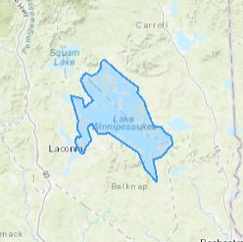

The location of the project can be viewed in Google Maps: 43°32'54.7"N 71°27'54.1"W - Google Maps

LAKE WINNIPESAUKEE LAKE LEVEL DATA GRAPH (nh.gov)
July – Lake level below average. Dam Bureau decreased outflow at the dam to the minimum release rate beginning July 15. Steady minimum discharge of 250 cfs (which was greater than inflow) through August and September until a brief increase in inflow at the end of September. Lake level continues dropping. Mid September lake level at or near lowest historical levels. Dam Bureau went to an emergency reduced release of 50 cfs starting 8am October 13, 2025.
Moderate drought from mid-August to mid-September when Severe Drought began. Severe drought continues now (October 16.)

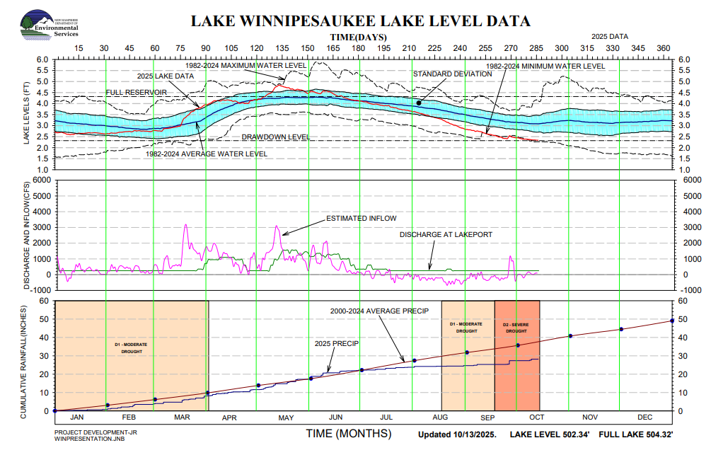

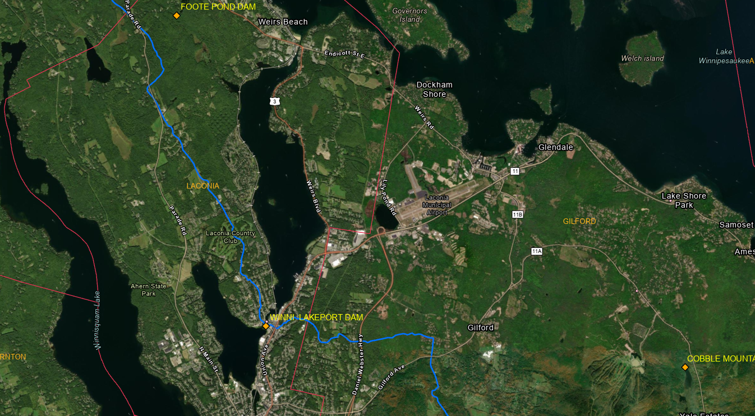
Winni Lakeport Dam location and environs

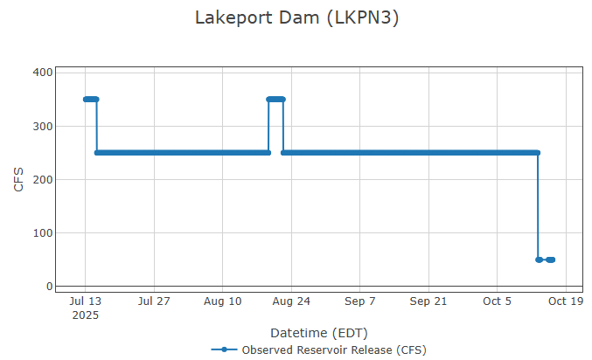
From Dam Bureau’s Lakeport Dam (LKPN3)
Data source: Real-Time Data & Information for Watersheds in New Hampshire (rtiamanzi.org)

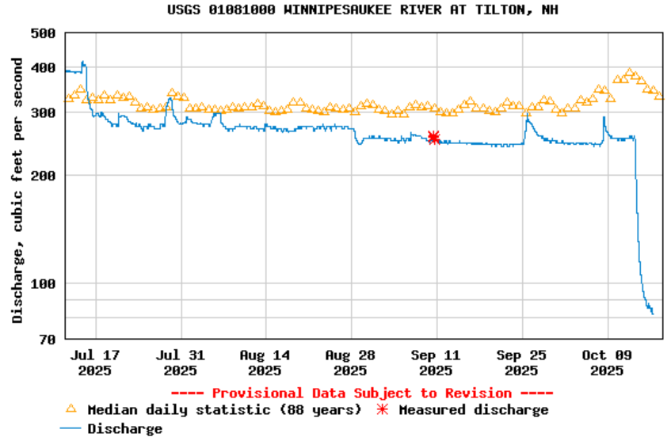
Winnipesaukee River flow data are at USGS Current Conditions for USGS 01081000 WINNIPESAUKEE RIVER AT TILTON, NH. The location of the Winnipesaukee gage can be seen at 43°26'30.3"N 71°35'18.1"W - Google Maps.

Penacook Upper Falls p-6689
eLibrary | General Search Results (ferc.gov) W I @ des Recon
For October meeting
8/28/25 - Record of conversation with applicant (Madeleine Mineau) to clarify applicant’s Final License Application for the Penacook Lower Falls and Penacook Upper Falls projects: Said an old pump house had no use in the project. Answered questions about the generating capacity and where it is measured and about the trash rack. When asked when the fish passage process will begin – replied more than 5 years after relicensing and after passage goals at Garvins Falls and below the dam have been met. Whether the project boundary is correctly described.

For August meeting
7/18/25 - Memo discussing the Updated List of Threatened, Endangered, Candidate, and Proposed Species generated by the U.S. Fish and Wildlife Service for the Penacook Upper Falls Hydroelectric Project. The tricolored bat and the monarch butterfly may be affected by the project. The northern long-eared bat was removed from the species list. There are no critical habitats within your project area under this office's jurisdiction.

The location of the project can be seen at: 43°16'58.5"N 71°36'04.5"W - Google Maps

Penacook Lower Falls p-3342
eLibrary | General Search Results (ferc.gov)
For October meeting
8/28/25 – Same as upper falls document.

9/29/25 – series of documents about the availability of the Environmental Assessment (EA) for the Lower Falls hydropower license. “The EA contains staff analysis of the potential environmental impacts of the project and concludes that licensing the project, with appropriate environmental protective measures, would not constitute a major federal action that would significantly affect the quality of the human environment.” FERC asked USF&WS if they concur with FERC’s conclusion that there the project is not likely to adversely affect the rare or endangered species identified. FERC explains why FERC believes NHF&G’s recommendations are inconsistent with the Federal Power Act and why the measures recommended in the Environmental Assessment are adequate.

For August meeting
7/18/25 – Same document as the Penacook Upper Falls.

The location of the project can be viewed in Google Maps at: https://www.google.com/maps/place/43%C2%B017'08.4%22N+71%C2%B035'42.1%22W/@43.285674,-71.5968567,686m/data=!3m2!1e3!4b1!4m4!3m3!8m2!3d43.285674!4d-71.595036?entry=ttu

Rolfe Canal p-3240
eLibrary | General Search Results (ferc.gov)
For October meeting
9/2/25 – 140pp. Environmental Assessment for Rolfe Canal.
Notice of availability of the Environmental Assessment for Rolfe Canal.
9/8/25 – Letter to NHF&G replying to the F&G 8/20/24 letter recommending several measures to protect fish and wildlife resources. FERC considered the recommendations, but did not recommend their adoption because they are inconsistent with the Federal Power Act or other law.

9/8/25 – FERC letter to USF&WS saying there is either no effect on small whorled pogonia, and “would not be sufficient to preclude both the survival and recovery of (i.e., jeopardize) the tricolored bat and the monarch butterfly.”

9/30/25 – Briar Hydro Associates’ comments on the Environmental Assessment for Rofle
Canal Hydroelectric Project.
- Corrected an error in their application.
- Requested that any license requirement for this bypass flow be stated as “100cfs or available inflow to York dam, whichever is less” to account for these circumstances where providing 100 cfs bypass flow would not be possible without drawing down the impoundment because inflow was less this year. Correcting the cause of dewatering of dwarf wedge mussels as lack of flow in the bypass reach not in the impoundment.
- Requested change to the wording of fish passage requirement to: We request that “installed” be replaced with “operated”. It is common to construct or install new fish passage structures during a construction season to begin operating it the following upstream fish passage season therefore the difference between installed or contracted and operated can represent approximately a year.
- Asked for more than three months from license issuance to develop an operation compliance monitoring plan.
- Corrected the flow division to 55 cfs over the spillway and 45 cfs through the slide gate instead of 50:50.
- Corrected the location of a water level sensor.
- Identified an incomplete sentence. And suggested that a word “sufficient” might be “insufficient.”

10/2/25 – NHF&G’s comments on the Environmental Assessment for Rolfe Canal
- Downstream fishway operations schedule of November 15th can be flexible/extended to November 30th maybe, if observations show eels different flows have different end of migration dates.
- Trash Rack Screens rely on modeled results not to determine survival through the turbines and recommending study parameters.
- Upstream eel passage- the single season of counting eels isn’t enough to determine whether the dam is a significant barrier especially for larger eels.
- Fishways operation and maintenance plan – routine inspections are needed b/c fish counts alone are likely to miss repairs that are needed which would not be seen without inspection. Gave an example.

10/8/25 - Briar Hydropower’s response to NHF&G’s 10/2/25 comments on the Environmental Assessment for Rolfe Canal. F&G expects fish passage at downstream dams in the next five years so it is premature to make operational decision based on the experimental fish friendly turbines that may or may not be installed. Briar believes a mid-November downstream passage end date is appropriate and “would still meet the downstream passage goals.” Briar will conduct effectiveness testing on all new fish passages. Briar is open to continuing discussion about optimizing upstream eel passage. Briar agrees with FERC that fish counts are sufficient.

For August meeting
7/18/25 – Same document as the Penacook Upper Falls.

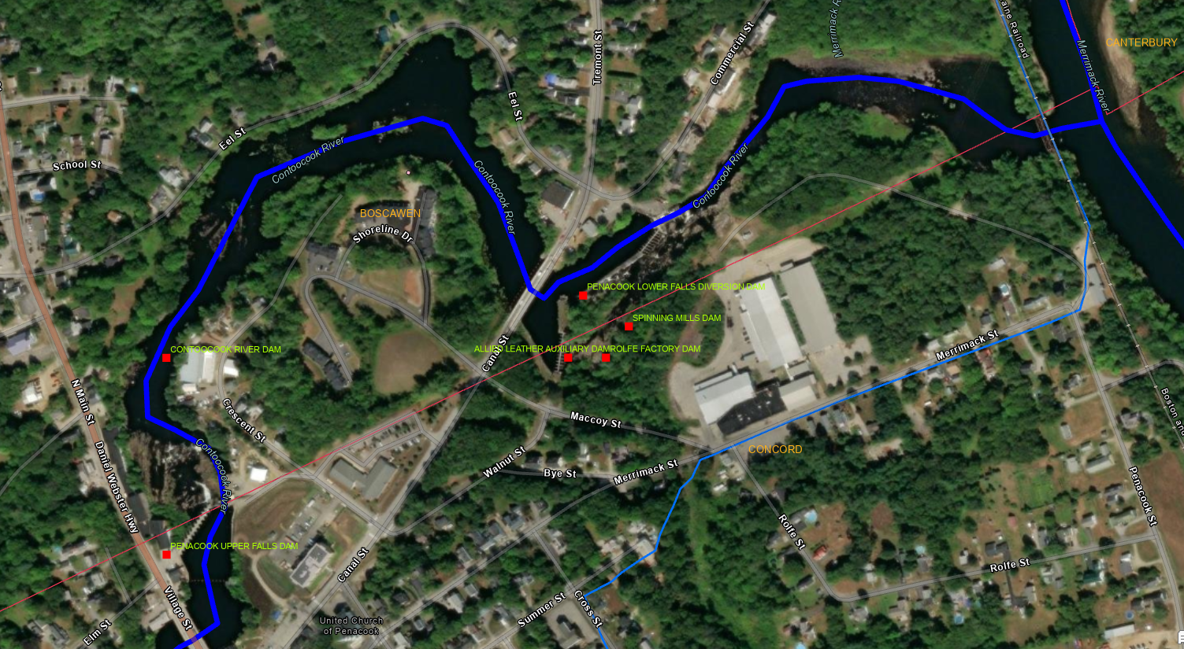
Penacook upper and lower Falls Dams and Rolfe Dam on the Contoocook River.

